WCSS Archive
Oldest Message First
From: Russell Sage <russosago@gmail.com>
To: Frederick N. Chase <fchase@gmail.com>
Cc: PETERS CARL L <clpeters2@sbcglobal.net>
Sent: Sunday, August 4, 2013 9:21 PM
Subject: More 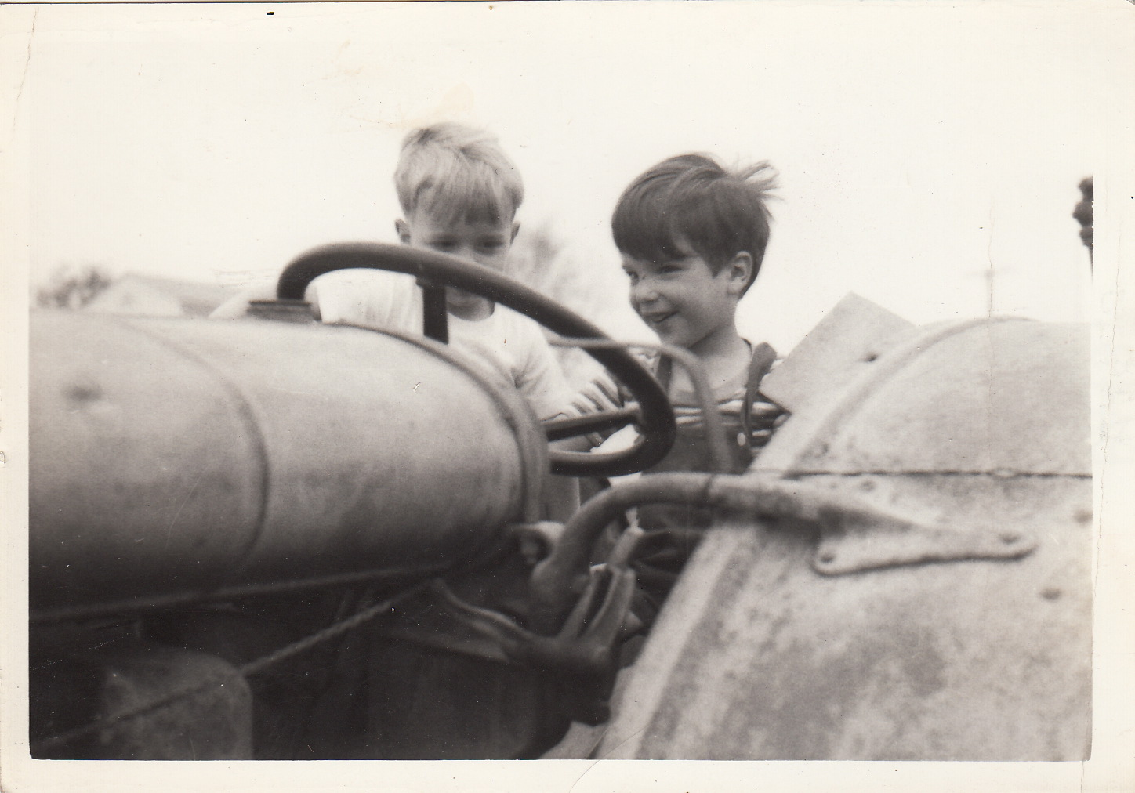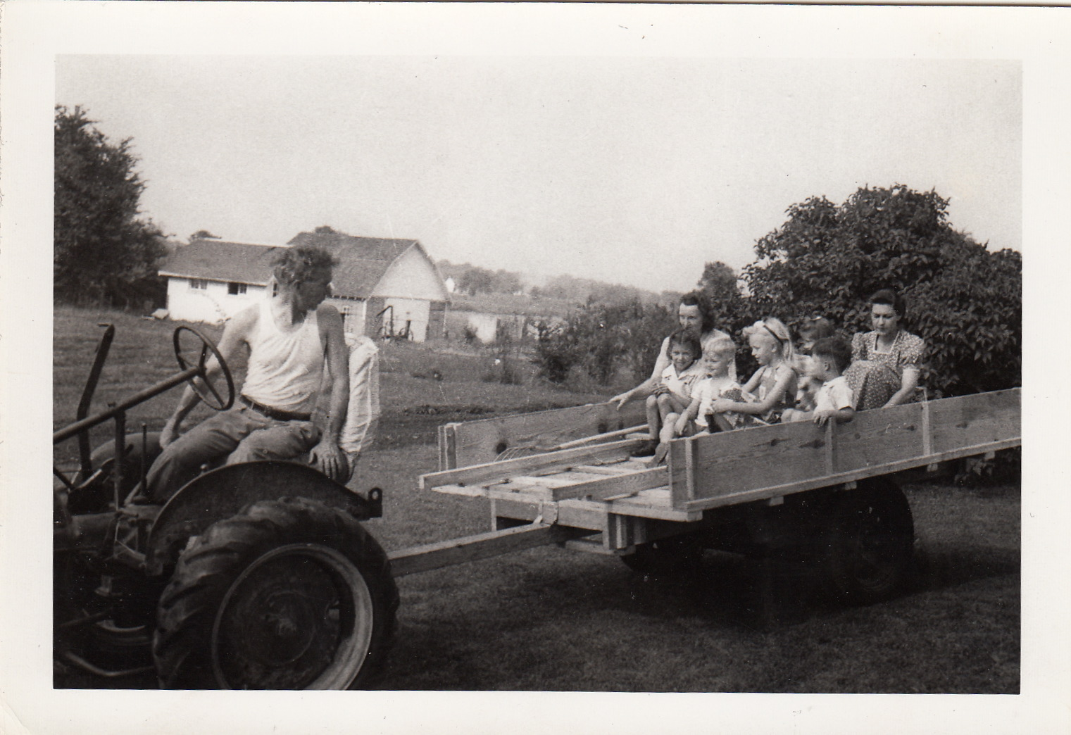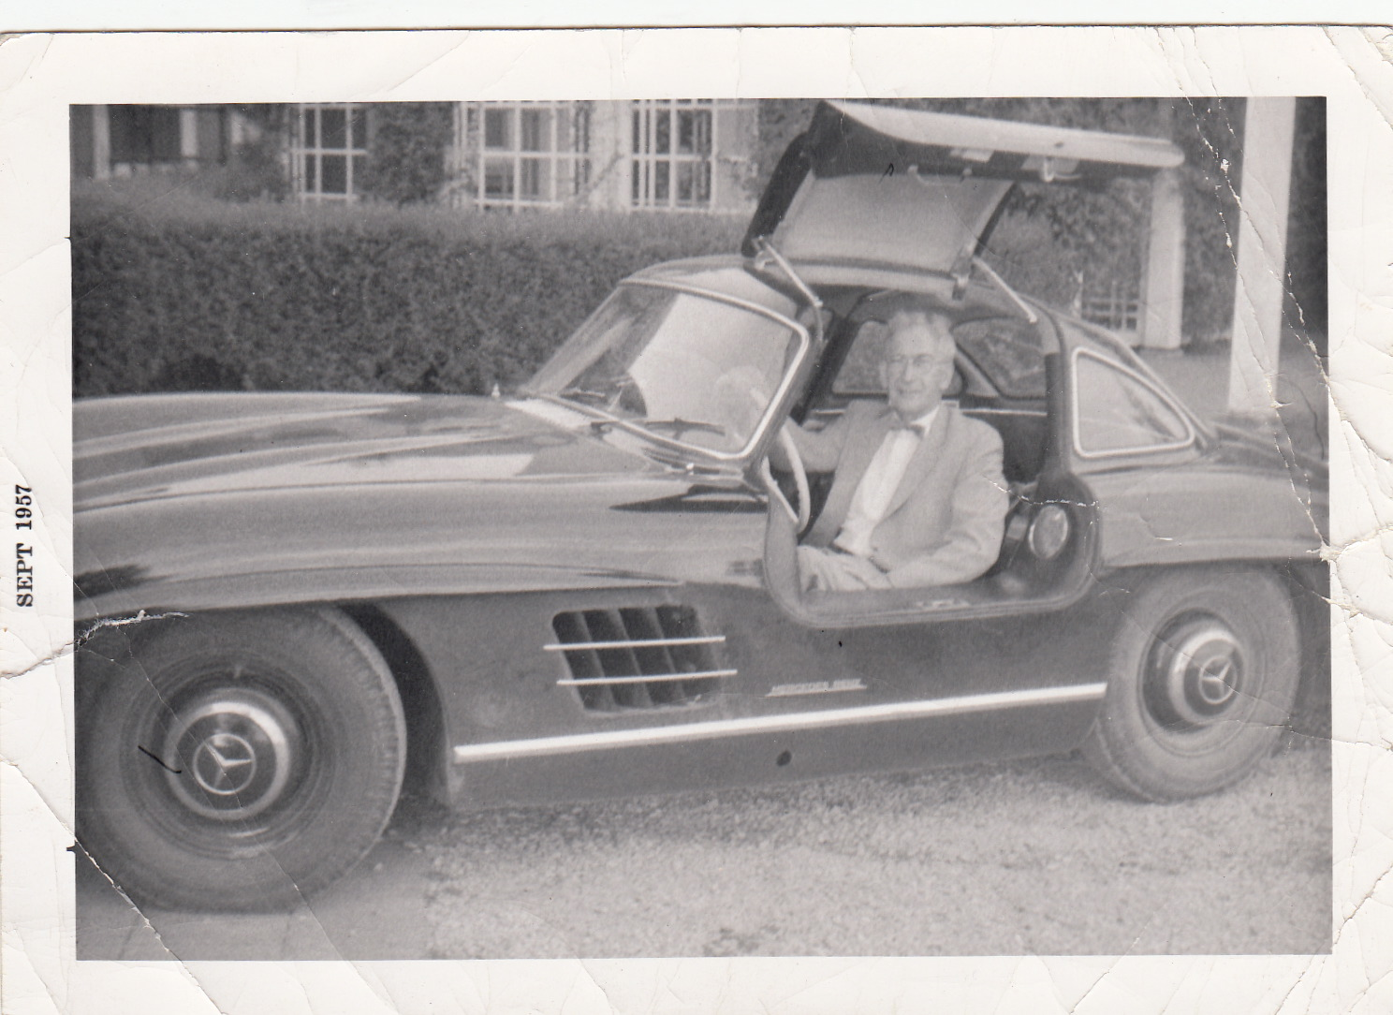

from: PETERS CARL L <clpeters2@sbcglobal.net>
to: Russell Sage <russosago@gmail.com>, "Frederick N. Chase" <fchase@gmail.com>
date: Sun, Aug 4, 2013 at 10:49 PM
subject: Re: More
Great pictures. Was that the barn before it burned down? It's hard to recognize the buildings, without the trees, which grew up in the chicken yard and around the Tack Building.

from: Frederick N. Chase <fchase@gmail.com>
to: Russell Sage <russosago@gmail.com>
date: Mon, Aug 5, 2013 at 7:38 AM
subject: Re: More
I "had" the top two of these but maybe what I had was a copy of what you had. I'll have to compare sharpness.
I think the middle picture is with the old barn burned down.
Love that one of you Dad and the 300SL!!!

from: Frederick N. Chase <fchase@gmail.com>
to: Carl Peters <clpeters2@sbcglobal.net>, Rusty Sage <russosago@gmail.com>, Ann Chase <annlouisechase@yahoo.com>
date: Mon, Sep 2, 2013 at 3:04 PM
subject: Was that the Barn?

"Was that the barn before it burned down? It's hard to recognize the buildings, without the trees, which grew up in the chicken yard and around the Tack Building."
That's a very good question!
I think, in the attached, that the pictures labeled 1943-1944 are probably after the old one burned down but before the new one was built.
And I'm mystified as to what that large white sandpile or ??? to the right of the little barn is!!
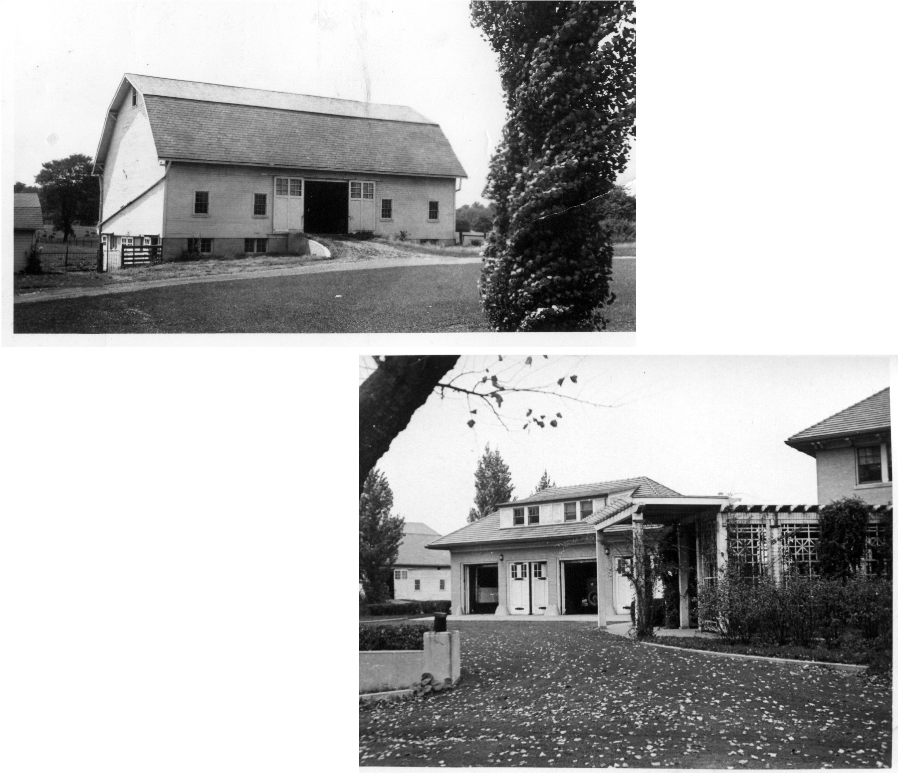1941 circa - old barn.jpg 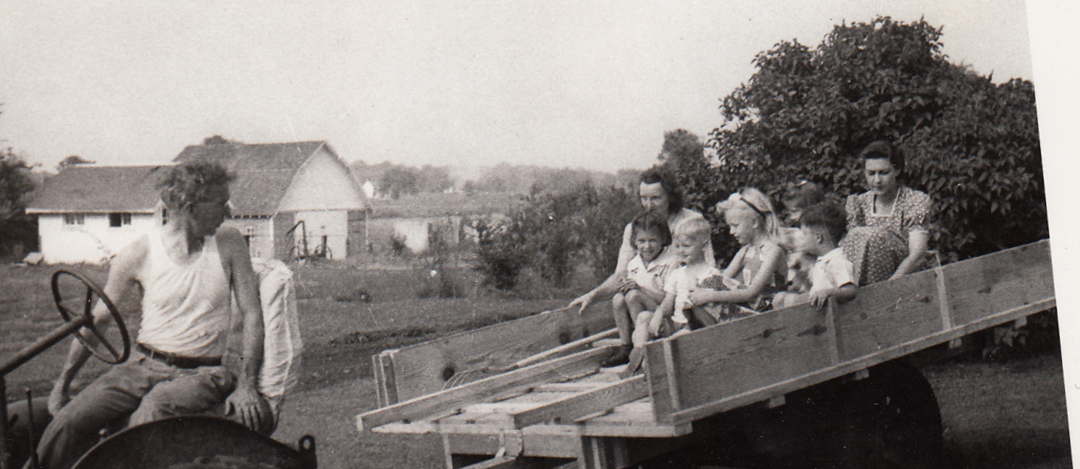1943-1944 Dr Sage hauling Chase & Sage kids & moms crop.jpg
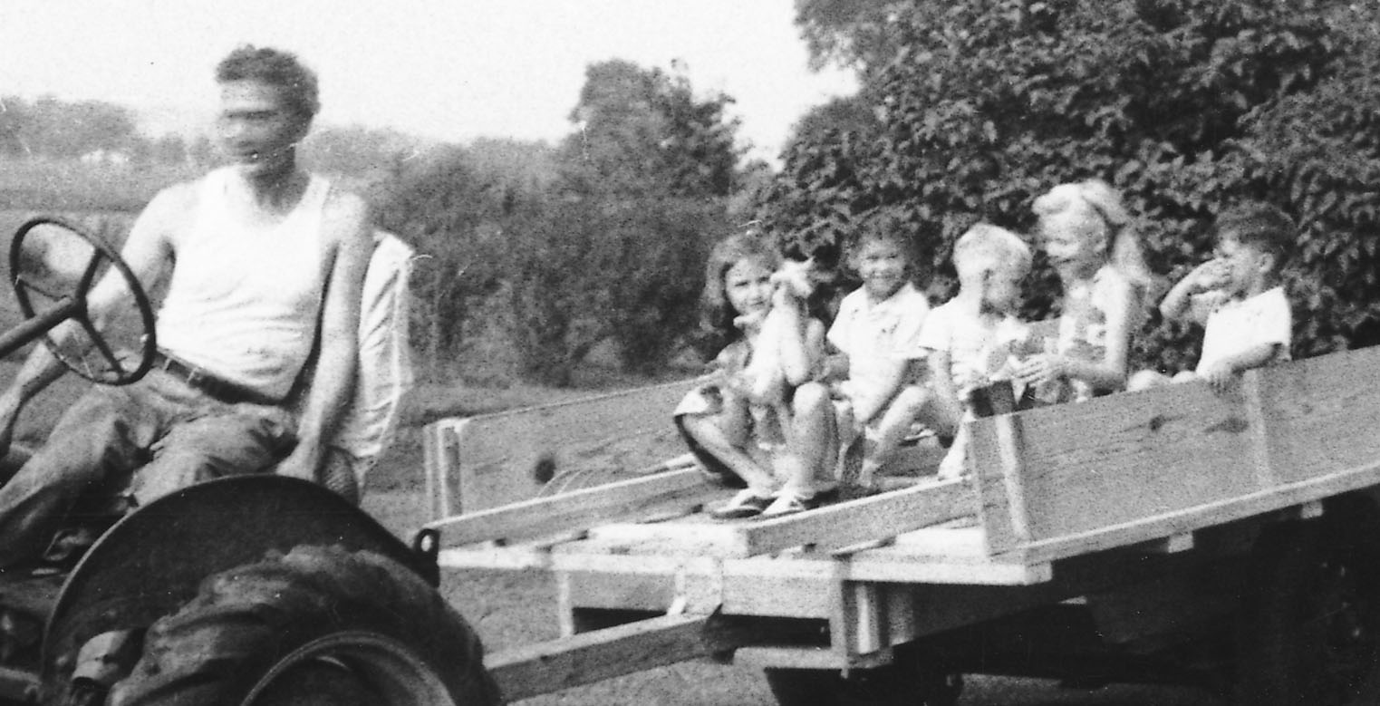 1943-1944_ Dr. Sage, Jeani Sage, Ann Chase, Rusty Sage, Janet Sage, Freddy Chase.jpg
A couple more pics to follow.

from: Frederick N. Chase <fchase@gmail.com>
to: Carl Peters <clpeters2@sbcglobal.net>, Rusty Sage <russosago@gmail.com>, Ann Chase <annlouisechase@yahoo.com>
date: Mon, Sep 2, 2013 at 3:06 PM
subject: Couple more barn pics

2 pics showing the big gate between the tack shed and the new barn.
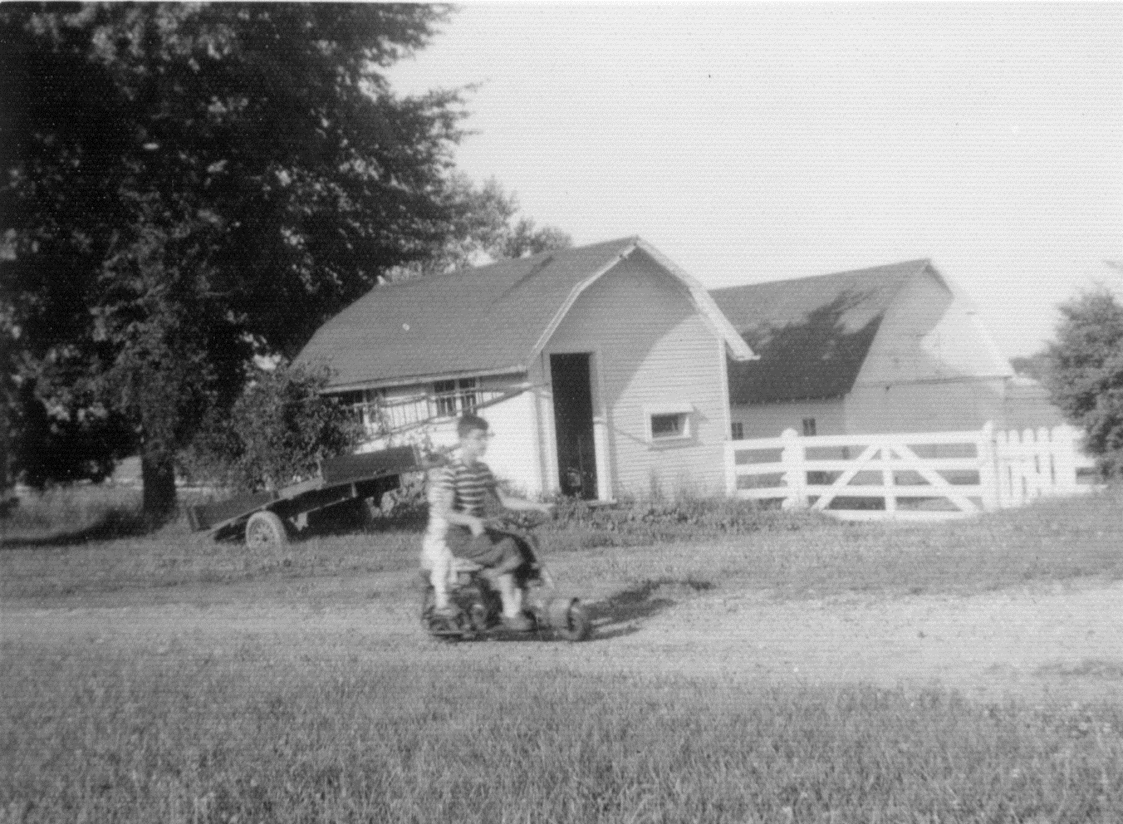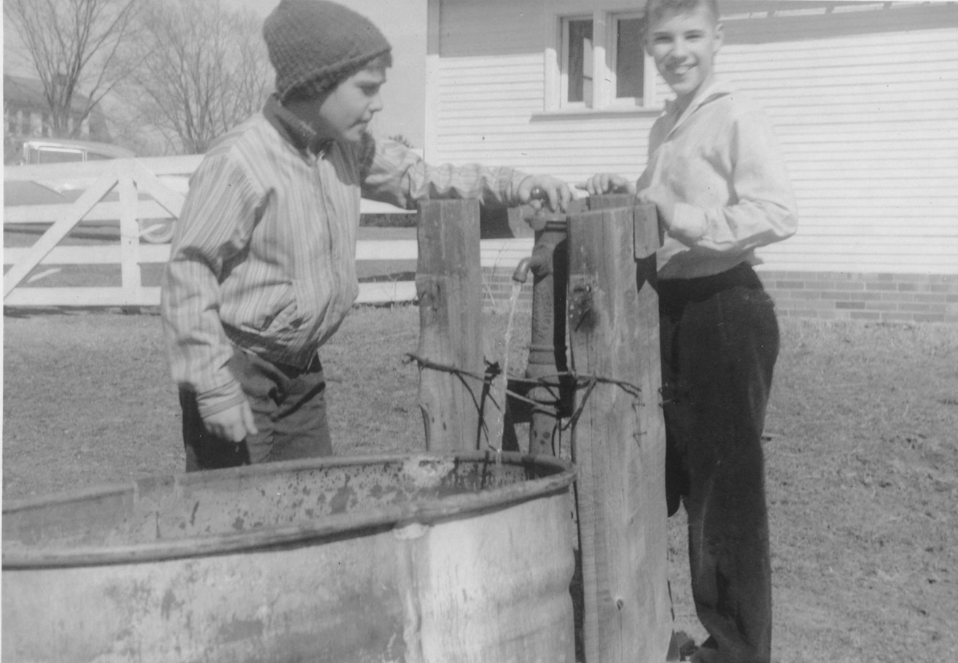

from: PETERS CARL L <clpeters2@sbcglobal.net>
reply-to: PETERS CARL L <clpeters2@sbcglobal.net>
to: "Frederick N. Chase" <fchase@gmail.com>, Rusty Sage <russosago@gmail.com>, Ann Chase <annlouisechase@yahoo.com>
date: Tue, Sep 3, 2013 at 8:37 AM
subject: Re: Was that the Barn?
The barn picture appears to be pre fire. I remember a lower roof on the barn. The other picture looks like the barn foundation after the fire, but before the barn was rebuilt. Rusty, did the barn burn after your dad bought the property?

from: Frederick N. Chase <fchase@gmail.com>
to: PETERS CARL L <clpeters2@sbcglobal.net>
cc: Rusty Sage <russosago@gmail.com>, Ann Chase <annlouisechase@yahoo.com>
date: Tue, Sep 3, 2013 at 11:03 AM
subject: Re: Was that the Barn?
I think I remember somebody, maybe my mom, saying that daddy went out and watered the chicken house with a hose while the barn burned -- to keep it from catching fire.
That would suggest that by the time the barn burned my family had moved out of the big house where, I think, Ann was born (1935) and into the white Dutch Colonial "cottage".
My genealogy program has this:
".....A Mr. Wilde built a home on College Avenue north of Indianapolis in the 1920s for $135,000.
Adele & CWC bought it for $35,000 in 1932 or 1933.
The home (minus the 'cottage' on 2 of the 40 acres where son JRC & family were to live) was sold by Adele for $26,000 on 19 July 1941 to Dr. Russell Anthas Sage."
We 3 boys were just under 3 years old then.

On Tue, Sep 3, 2013 at 8:37 AM, Carl wrote: "The barn picture appears to be pre fire."
Yes, that good one is definitely pre-fire.

On Tue, Sep 3, 2013 at 8:37 AM, Carl wrote: "I remember a lower roof on the barn. The other picture looks like the barn foundation after the fire, but before the barn was rebuilt."
Problem is, the barn foundation is farther around to the right, behind those bushes!! I sent so many pictures because each one helps us to remember just where the big barn was. And it was not where that big white sandpile or field or ?? was. That is too far to the left.
Rusty, did the barn burn after your dad bought the property?

from: Russell Sage <russosago@gmail.com>
to: "Frederick N. Chase" <fchase@gmail.com>
cc: Carl Peters <clpeters2@sbcglobal.net>
date: Tue, Sep 3, 2013 at 7:04 PM
subject: Re: Was that the Barn?
That is a picture of the old barn. It burned down before we moved in. The picture of the house and garage show an old car in the garage. You can just make out that the spare tire has spokes. Could be a model A ford. That was taken before we moved in also.

from: Ann Chase <annlouisechase@yahoo.com>
to: "Frederick N. Chase" <fchase@gmail.com>
date: Wed, Sep 4, 2013 at 9:26 AM
subject: Re: Was that the Barn?

in reply to Sent: Monday, September 2, 2013 3:04 PM :

fabulous pictures!! Yes, I think the first one is of the old barn. Sure looks like it.

from: Ann Chase <annlouisechase@yahoo.com>
to: "Frederick N. Chase" <fchase@gmail.com>
date: Wed, Sep 4, 2013 at 9:30 AM
subject: Re: Was that the Barn?
I am virtually positive the barn burned down after the Sages bought the property.
I remember it burned for 2 days and Mom was frantic about all the strangers who flocked to see the fire and wandered all over both properties.
She was sure they were up to no good.

from: Frederick N. Chase <fchase@gmail.com>
to: Ann Chase <annlouisechase@yahoo.com>
date: Wed, Sep 4, 2013 at 11:02 AM
subject: Re: Was that the Barn?
Rusty sent this:
"That is a picture of the old barn. It burned down before we moved in. The picture of the house and garage show an old car in the garage. You can just make out that the spare tire has spokes. Could be a model A ford. That was taken before we moved in also. "

Do you remember the Sages being there during the fire?
Do you remember Daddy hosing down the chicken house?
How old were you?
Thanks,
-Fred

from: Frederick N. Chase <fchase@gmail.com>
to: Rusty Sage <russosago@gmail.com>
cc: Carl Peters <clpeters2@sbcglobal.net>
date: Wed, Sep 4, 2013 at 4:44 PM
subject: Barn Fire

Rusty you sent
".... It burned down before we moved in. ..."

about the same time Ann sent this:
"I am virtually positive the barn burned down after the Sages bought the property. I remember it burned for 2 days and Mom was frantic about all the strangers who flocked to see the fire and wandered all over both properties. She was sure they were up to no good."

I sent Ann this, but haven't heard back:

Do you remember the Sages being there during the fire?
Do you remember Daddy hosing down the chicken house?
How old were you?
Thanks,
-Fred

from: Russell Sage <russosago@gmail.com>
to: "Frederick N. Chase" <fchase@gmail.com>
cc: Carl Peters <clpeters2@sbcglobal.net>
date: Wed, Sep 4, 2013 at 6:27 PM
subject: Re: Barn Fire
I just don't remember the barn burning.
I do remember my Dad saying that during the war there was some restriction on building new buildings.
So he put in an application to just repair this burned down barn and it was approved by whoever approves such things so he was able to repair/rebuild it.

from: Ann Chase <annlouisechase@yahoo.com>
to: "Frederick N. Chase" <fchase@gmail.com>
date: Fri, Sep 6, 2013 at 9:29 AM
subject: Re: Was that the Barn?

I don't remember Gran or Granddad being part of the barn-burning picture. Perhaps the fire occurred after the Sages bought the property but before they moved in? Of course, my memories are those of a small child...

from: Frederick N. Chase <fchase@gmail.com>
to: Ann Chase <annlouisechase@yahoo.com>
date: Fri, Sep 6, 2013 at 10:15 AM
subject: Re: Was that the Barn?

As I noted before, we know:
The home (minus the 'cottage' on 2 of the 40 acres where son JRC & family were to live) was sold by Adele for $26,000 on 19 July 1941 to Dr. Russel Anthas Sage."

So you (born July 20, 1935) would have been just 7 6 yrs old when the home was sold.
Can you connect being 7 6 --a birthday party maybe-- with being before or being after the barn burning?

from: Ann Chase <annlouisechase@yahoo.com>
reply-to: Ann Chase <annlouisechase@yahoo.com>
to: "Frederick N. Chase" <fchase@gmail.com>
date: Sat, Sep 7, 2013 at 9:20 AM
subject: Re: Was that the Barn?

I have a picture somewhere of myself and Jeanie and Janet sitting under the maple tree to the west of our house celebrating my birthday.
I believe it was my sixth birthday. That would have been July 20, 1941.
I remember the Sage's St. Bernard jumped on my back - I still have the scars!
Maybe the barn is in the background, but I don't know where the picture is!

from: Frederick N. Chase <fchase@gmail.com>
to: Ann Chase <annlouisechase@yahoo.com>
cc: Rusty Sage <russosago@gmail.com>, Carl Peters <clpeters2@sbcglobal.net>
date: Fri, Sep 13, 2013 at 2:48 PM
subject: Re: Was that the Barn?

Ann,
If it was your 6th birthday (July 20, 1941) as you think, then Dr. Sage just closed on the big home the day before!!!
So you gotta find that picture so we can (hopefully) see what was behind you at the top of the ramp to the barn!!

from: Ann Chase <annlouisechase@yahoo.com>
to: Fred Chase <fchase@gmail.com>
date: Wed, Nov 13, 2013 at 10:21 AM
subject: 1941 Photos Finally !!

Hi Fred,
Sorry to take so long getting these to you but it took me a while to find them. They were in an old album I hadn't looked in in years, but the birthday pictures were there. I think there is yet another picture somewhere, but that may take another while to find. I think I remember one with clearer focus. Hope I'm right. but, these were certainly taken on my birthday, July 20, 1941. The others of you were on the same page in the album and I thought you might enjoy seeing them too. Much love, Ann
9 Attachments

from: xxxxxxxxxxxxx.com>
to: xxxxxxxxxxxxxxxxxxxxxxxxx.com>
date: xxxxxxxxxxxxxxxxxxxxxx 10:21 AM
subject: xxxxxxxxxxxxxxxxxxxxxxxxxxxxxxxx

First, consider Croquet 1.jpg, Croquet 3.jpg, Croquet 3.jpg. These are undated but in Ann’s album right next to some party ones of July 20, 1941. I suspect all 3 of these are looking across the baseball diamond and west past the end of Sage’s garage, with Croquet 1.jpg giving a view farthest to the right. This makes it look kinda like there isn’t even the tack room there. Did the tack room or the little barn survive burn down too?
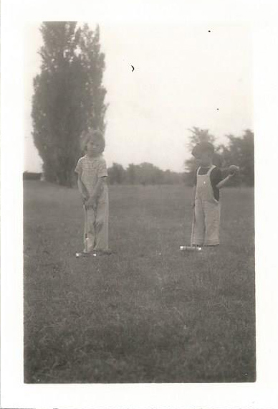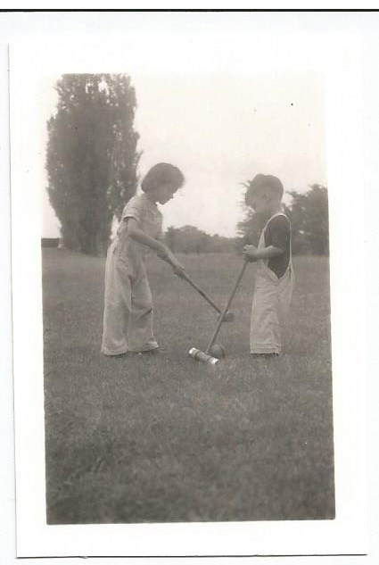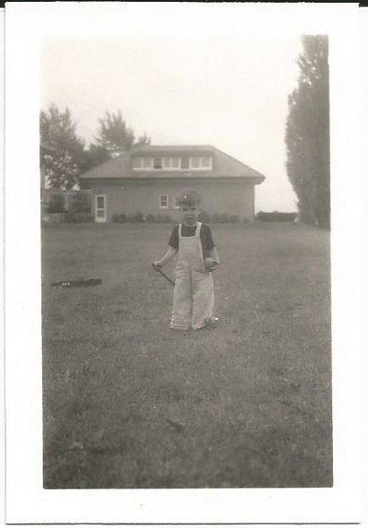
Croquet 1.jpg Croquet 2.jpg Croquet 3.jpg

We now have 4 pictures of the party (with the prospect of Ann finding one more in better focus)! Here they are.
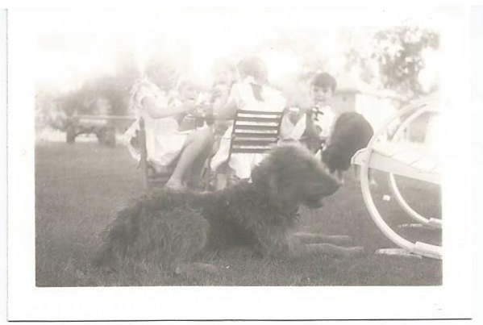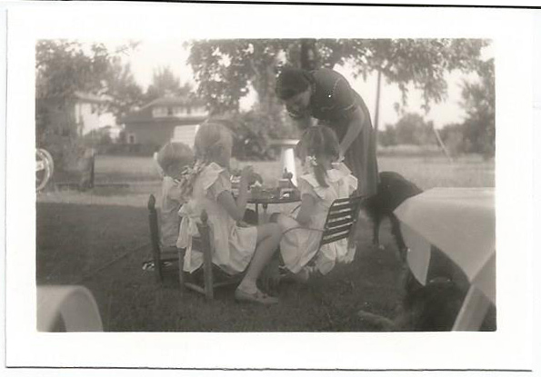
19410720 Ann Chase 6.jpg 19410720 Ann Chase 8.jpg
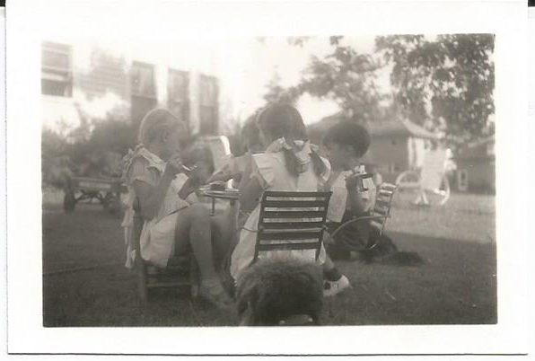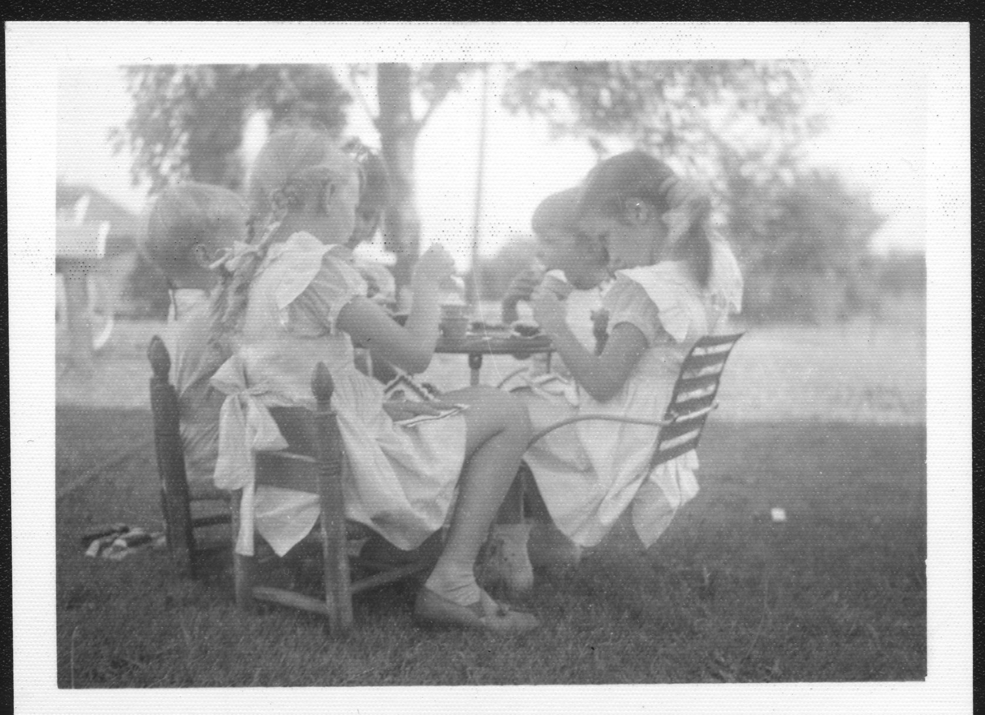
19410720 Ann Chase 9.jpg 19410720 Party
There is a black shaggy dog in a couple of the pictures. And those big round “bicycle wheels seem to actually be 2 - 3 white lawn chairs with wheel-armrests. Still nothing I see to indicate there is a barn to the right.

And to round this batch out, here is a picture of the old chicken house. I put a second image at the right of (I guess) me at the right and in front of the garage.
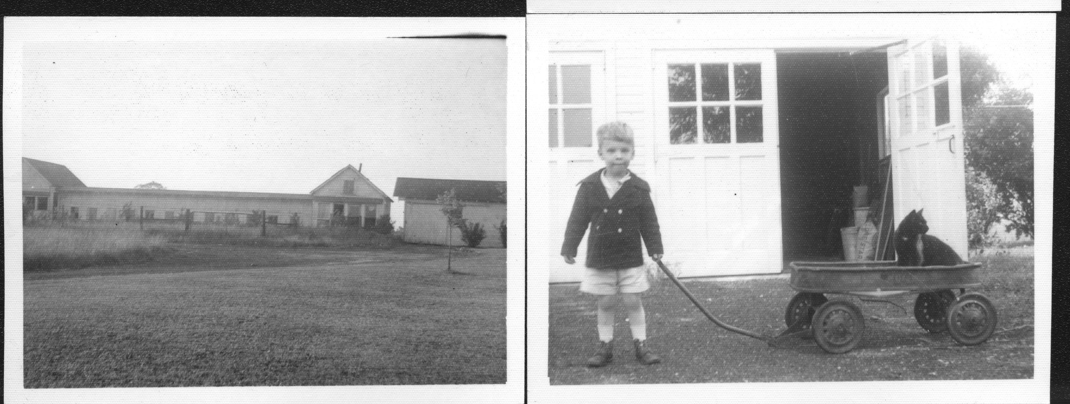
I’m guessing that the garage was remodeled some, adding doors with glass windows, and that when the chicken house was torn down, the building with the little chimney became my workshop. Anybody know?

The old barn had main upper door which slid apart on tracks to open. At its left end it had one small window high up at the apex. It was probably built in the 1920s. The date it burned down is shown in the chronology below.
The new barn had main upper doors which swung outwards to open. There were twelve small window panes at the top of each door. The left end of the barn had a door about 4 feet square which swung (out, if I recall) onto the barnyard and was a bit dangerous. Ann: “I have vivid memories of the barn burning, but no particular memories of the rebuilding.” This barn was probably destroyed by demolition.

Chronology prepared fall 2013.

1920s | Mr. Wilde built a home on 40 acres on College Avenue north of Indianapolis in the 1920s for $135,000.
1932 or 1933 | Adele & CWC bought it for $35,000 in 1932 or 1933.
November 1938 probably | Jim and Louise Chase move out of their parent’s house across into the Dutch Colonial Cottage a(instead of to William’s Creek!).
1940 or Spring 1941? | Adele & Charles W. Chase moved to Chicago. There is an extensive series of pictures of the Wilde-Chase-Sage home, interior and exterior, which Ann thinks were taken shortly before they moved. Probably spring 1941.
Date of the Barn fire | Rusty: "I just don't remember the barn burning.” Fred: “I think I remember somebody, maybe my mom, saying that daddy went out and watered the chicken house with a hose while the barn burned -- to keep it from catching fire.” See picture of chicken house. Ann: "I don't remember Gran or Granddad being part of the barn-burning picture. Perhaps the fire occurred after the Sages bought the property but before they moved in? Of course, my memories are those of a small child..." Ann: "I remember it burned for 2 days and Mom was frantic about all the strangers who flocked to see the fire and wandered all over both properties. She was sure they were up to no good." Fred: “Is that a direct recollection? I.e., did you actually see the flames, etc or are you recalling the telling by an elder of what happened?” Ann: “No question about it. I viewed the fire personally. Very clear memories. It went on and on. Also clearly remember Mom's comments.” “You [Freddy] and Rusty would have been 3-4 years old when the barn burned and I would have been 6-7.”
July 19, 1941 | The home (minus the 'cottage' on 2 of the 40 acres where son JRC & family were to live) was sold by Adele Chase for $26,000 on 19 July 1941 to Dr. Russell Anthas Sage."
July 20, 1941 | Ann’s 6th birthday. See pictures.
Summer 1941? | Dr. Sage takes the two families around behind his tractor. See pictures.
1942-1944? | The Barn is rebuilt during the war. Rusty: "I just don't remember the barn burning. I do remember my Dad saying that during the war there was some restriction on building new buildings. So he put in an application to just repair this [burned down] barn and it was approved by whoever approves such things so he was able to repair/rebuild it."
1975, circa | We have a newspaper clipping labeled 1975, circa - Sage Barn,owned by Church.jpg
Post 1975 | New Barn torn down I filled in.

